**Optimizing User, Group, And Role Management with Access Control and Workflow**

**TeamId: NM2025TMID19744**

**TeamMembers : 5**

**TeamLeader : PRIYADHARSHINI G**

**TeamMember 1 : DEEPA A**

**TeamMember 2 : DHIVYA LAKSHMI M M**

**Team Member 3 : PRIYADHARSHINI M**

**Team Member 4 : VINODHINI D**

**Problem Statement:**  In a small project management team consisting of a Project Manager (Alice) and a Team Member (Bob), there is a need to efficiently manage project tasks and ensure accountability throughout the project lifecycle. The current system lacks clear role definitions, access controls, and a structured workflow, leading to confusion regarding task assignments and progress tracking.

**Objective:** Optimize user, group, and role management with secure access control and workflow automation in ServiceNow.

Skills: ServiceNow platform, Access control, Workflow automation, Data structures, Team collaboration.

**TASKINITIATION**

**Milestone1: Users**

**Activity1:CreateUsers**

1. Openservicenow
2. ClickonAll>>search for users
3. SelectUsersundersystemsecurity
4. Clickon new
5. Fillthefollowingdetailstocreate anewuser
6. Clickon submit

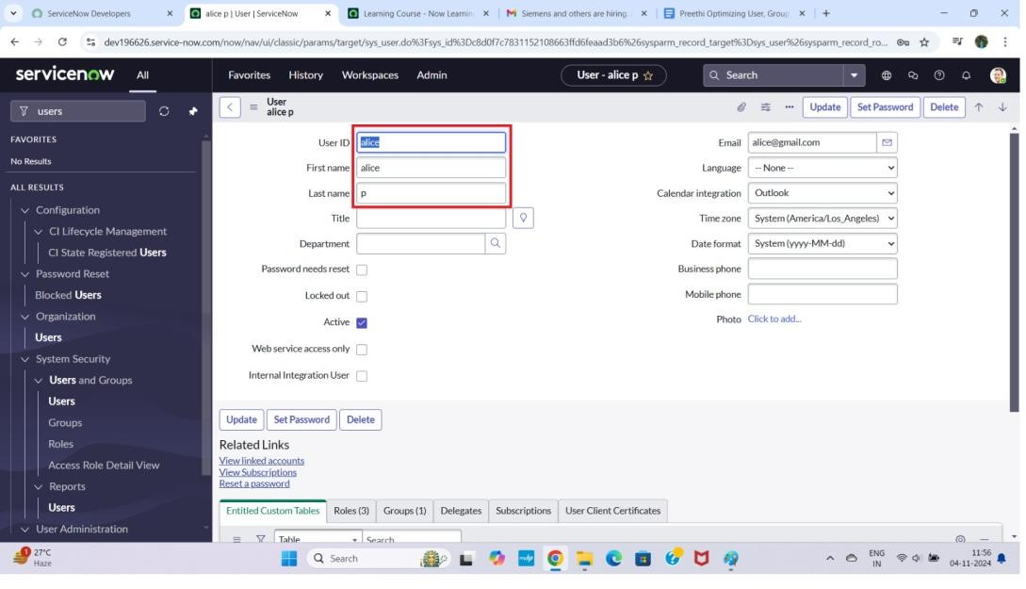

# Createonemore user:

1. Createanotheruserwiththefollowingdetails
2. Clickon submit

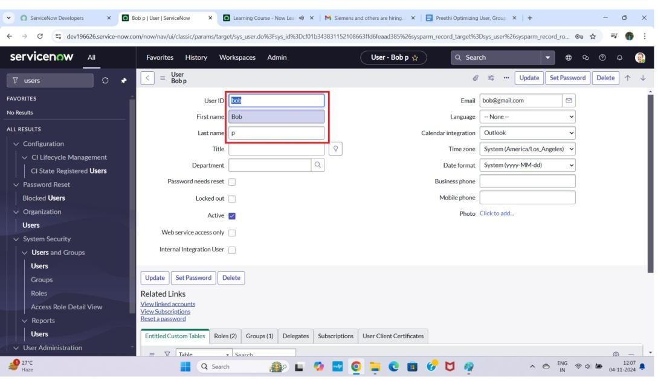

**Milestone2:Groups**

**Activity1:CreateGroups**

1. Openservicenow.
2. ClickonAll>>search for groups
3. Selectgroupsundersystem security
4. Clickon new
5. Fillthefollowingdetailstocreate anew group
6. Clickon submit

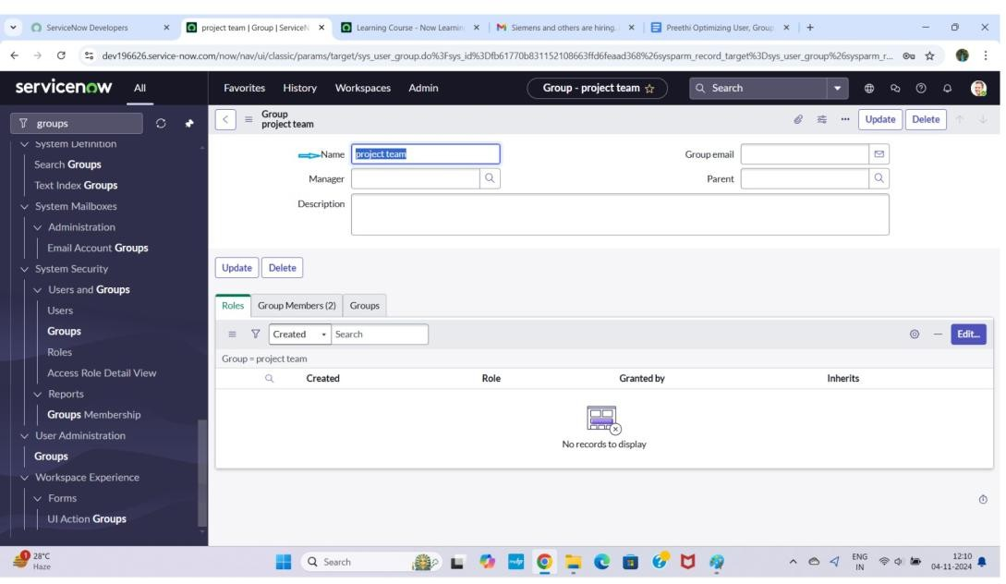

**Milestone3:Roles**

**Activity1:Createroles**

1. Openservicenow.
2. ClickonAll>>search for roles
3. Selectrolesundersystem security
4. Clickon new
5. Fillthefollowingdetailstocreate anew role
6. Clickon submit

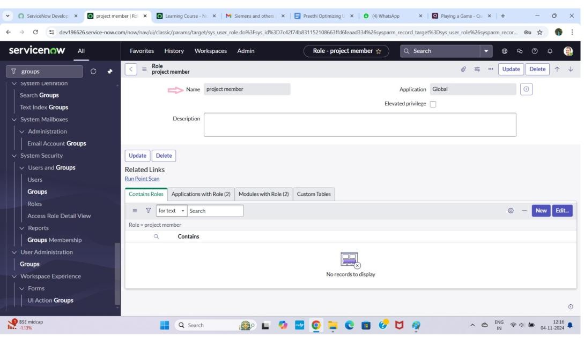

# Createonemorerole:

1. Createanother rolewiththefollowing details
2. Clickon submit

**Milestone4:TableActivity1:CreateTable**

1. Openservicenow.
2. ClickonAll>>search for tables
3. Selecttablesundersystem definition
4. Clickon new
5. Fillthefollowingdetailstocreateanewtable Label : project table

ChecktheboxesCreatemodule&Createmobilemodule

1. Undernewmenuname:projecttable
2. Undertable columnsgivethecolumns

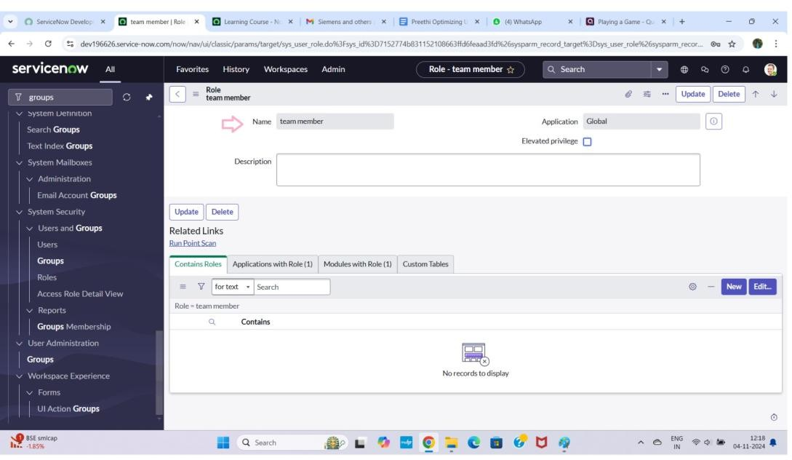

1. Clickon submit

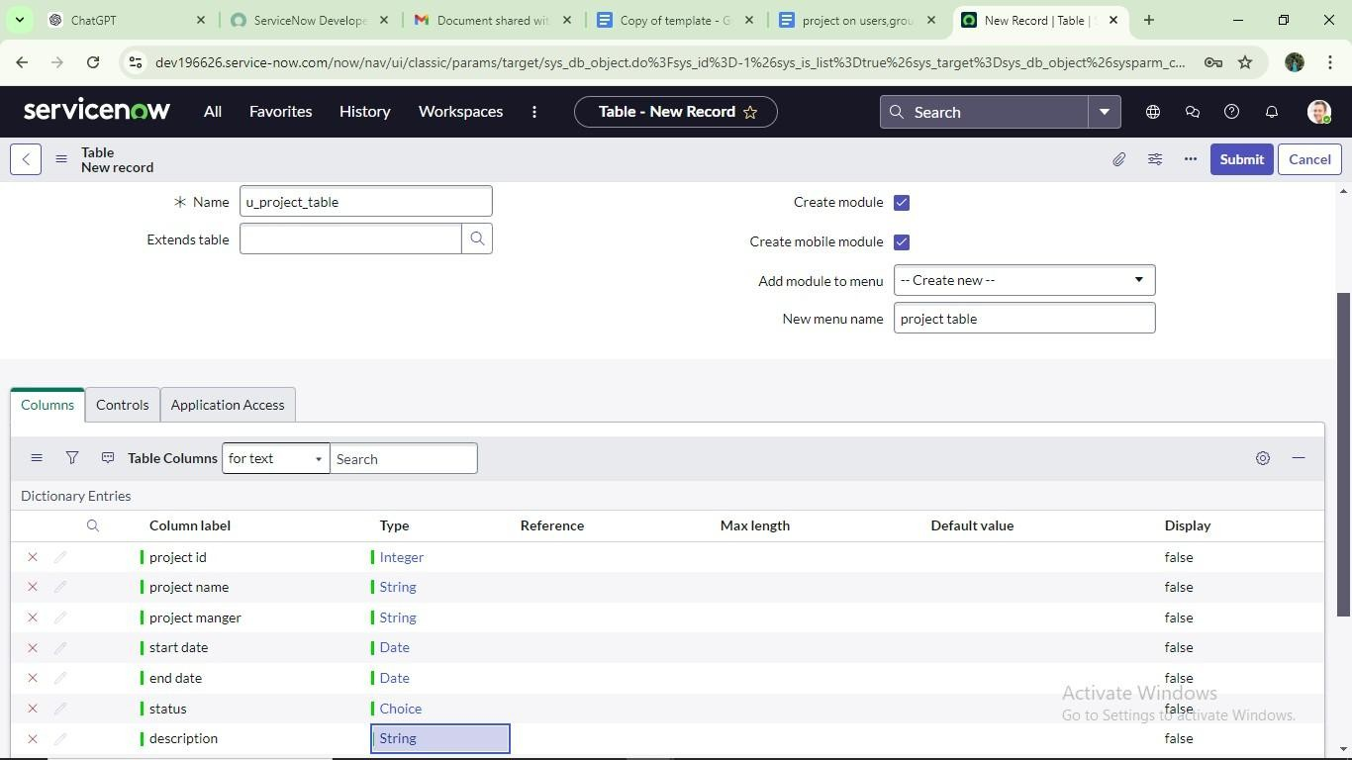

# Createonemoretable:

1. Createanothertable as:tasktable 2andfillwithfollowing details.
2. Clickon submit.

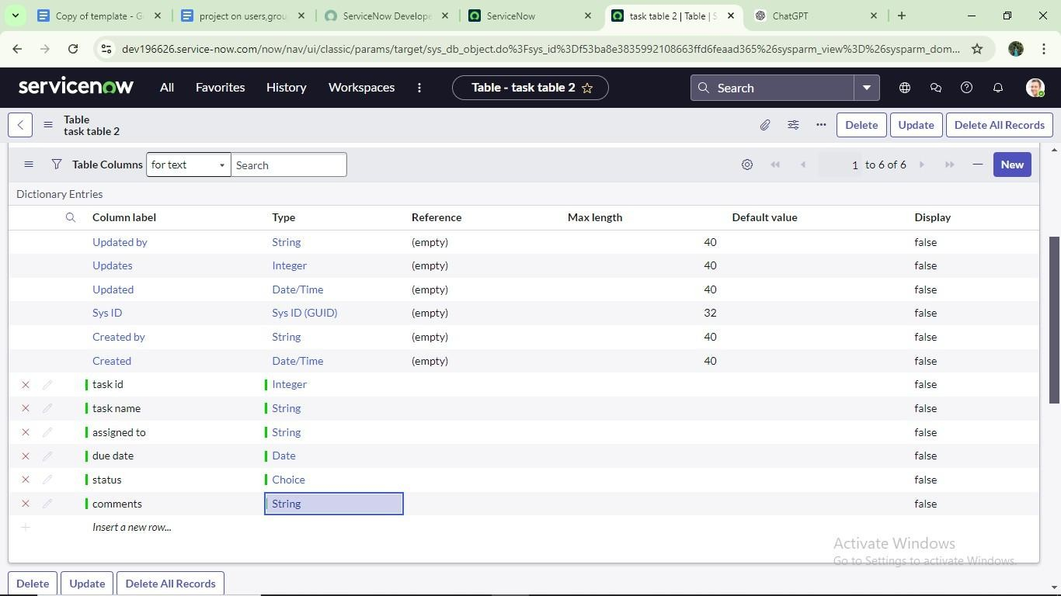

**Milestone5:Assignuserstogroups**

**Activity1:Assignuserstoprojectteamgroup**

* 1. Openservicenow.
  2. ClickonAll>>searchfor groups
  3. Selecttablesundersystem definition
  4. Selecttheprojectteamgroup
  5. Undergroup members
  6. Clickon edit
  7. Selectalicep and bobp and save

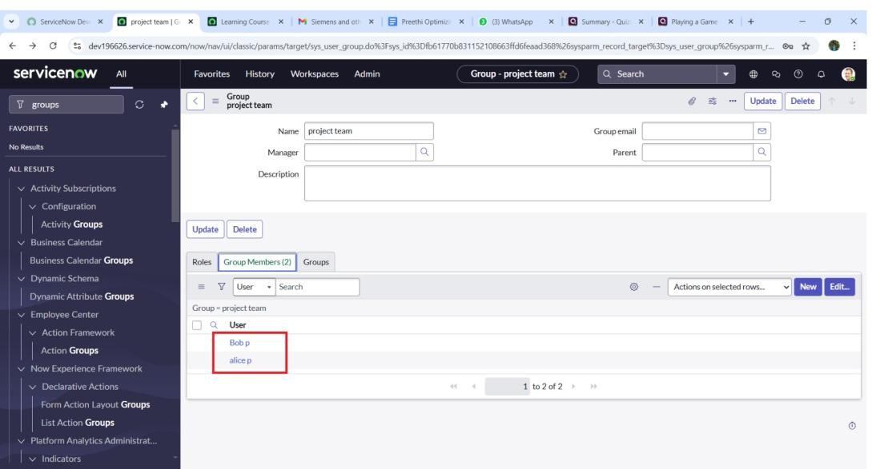

**Milestone 6 :Assignroles to users Activity1:Assignrolestoaliceuser**

1. Openservicenow.ClickonAll>>searchforuser
2. Selecttablesundersystem definition
3. Selecttheprojectmanageruser
4. Underproject manager
5. Clickon edit
6. Selectprojectmemberandsave
7. clickoneditaddu_project_tablerole andu_task_tablerole
8. clickon saveandupdate theform.

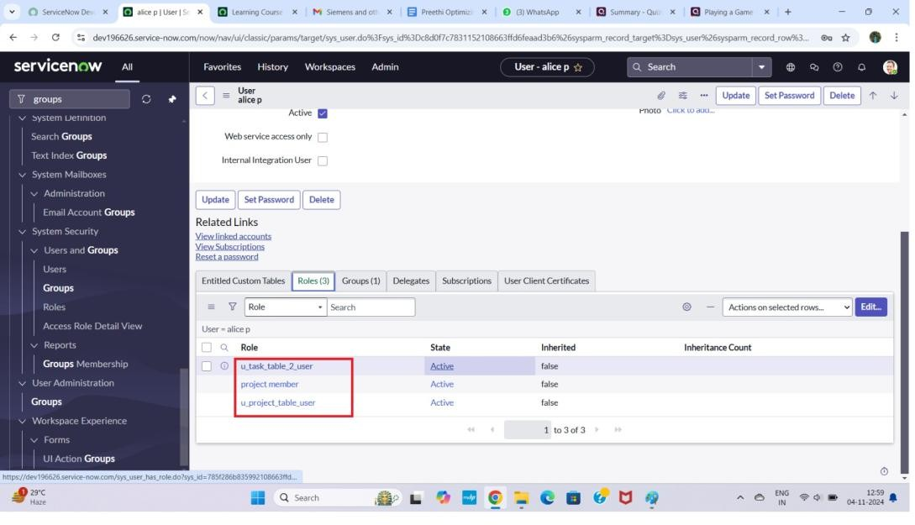

**Activity2:Assignrolestobob user**

1. Openservicenow.ClickonAll>>searchforuser
2. Selecttablesundersystem definition
3. Selectthebobp user
4. Underteammember
5. Clickon edit
6. Selectteammemberandgivetable roleandsave
7. ClickonprofileiconImpersonate userto bob
8. Wecanseethetasktable2.

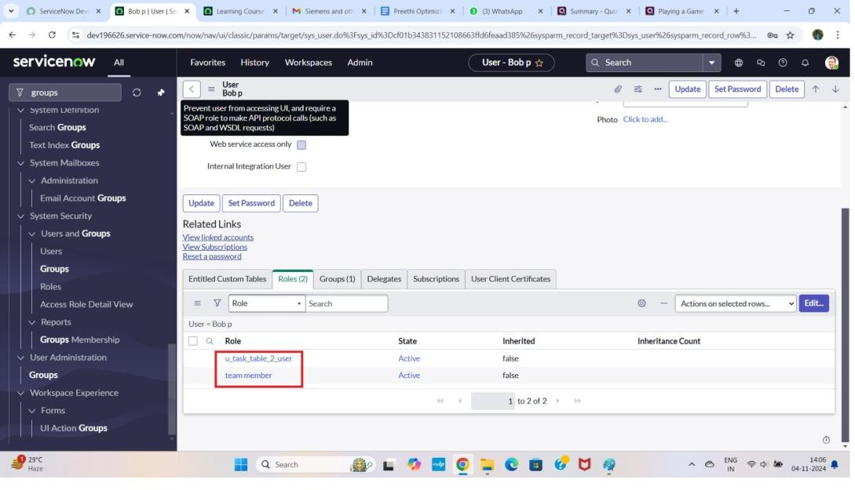

**Milestone7:Applicationaccess**

**Activity1:Assigntableaccesstoapplication**

1. whilecreatingatableitautomatically createaapplicationandmoduleforthat table
2. Gotoapplicationnavigatorsearch forsearchprojecttable application
3. Clickoneditmodule
4. Giveprojectmemberrolestothat application
5. Searchfortasktable2 andclickoneditapplication.
6. Givetheprojectmember andteammember rolefortasktable2 application

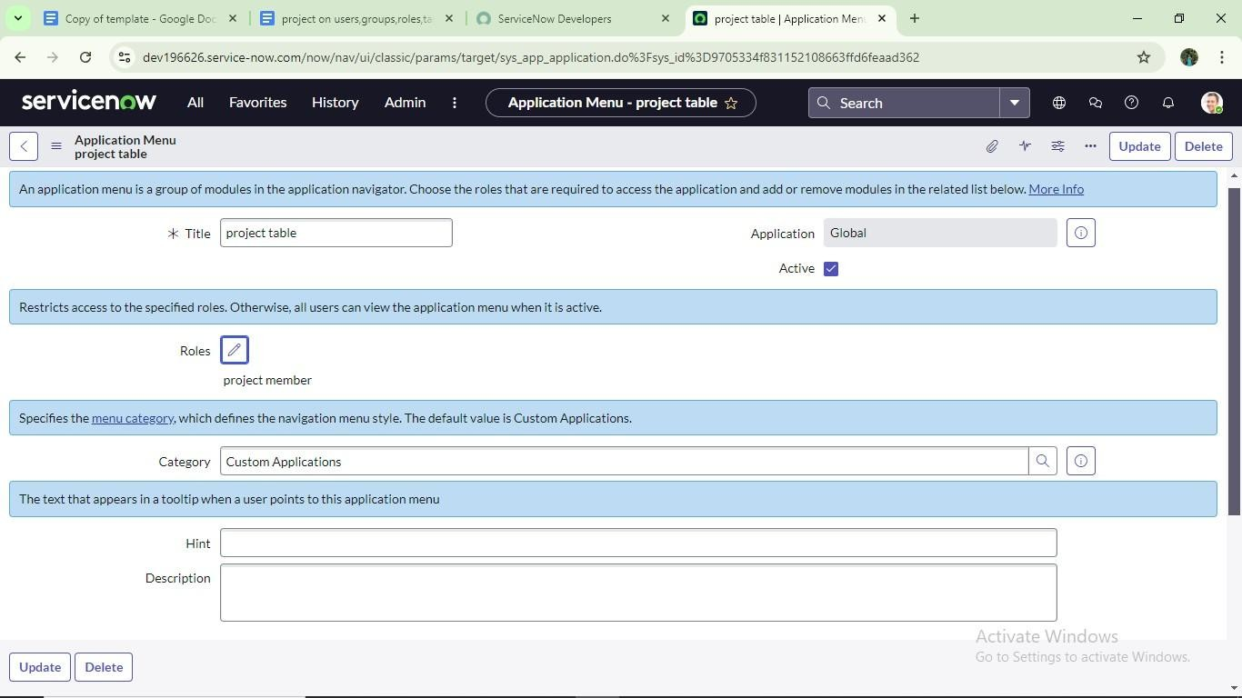

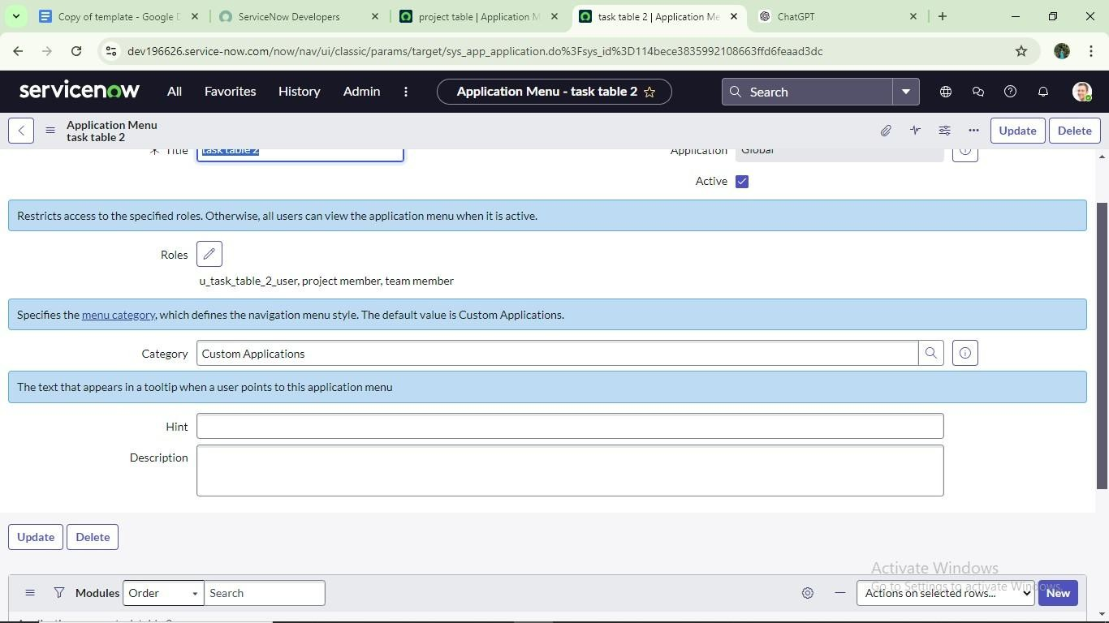

**Milestone8:AccesscontrollistActivity1:CreateACL**

1. Openservicenow.
2. ClickonAll>>search forACL
3. SelectAccessControl(ACL)undersystem security
4. 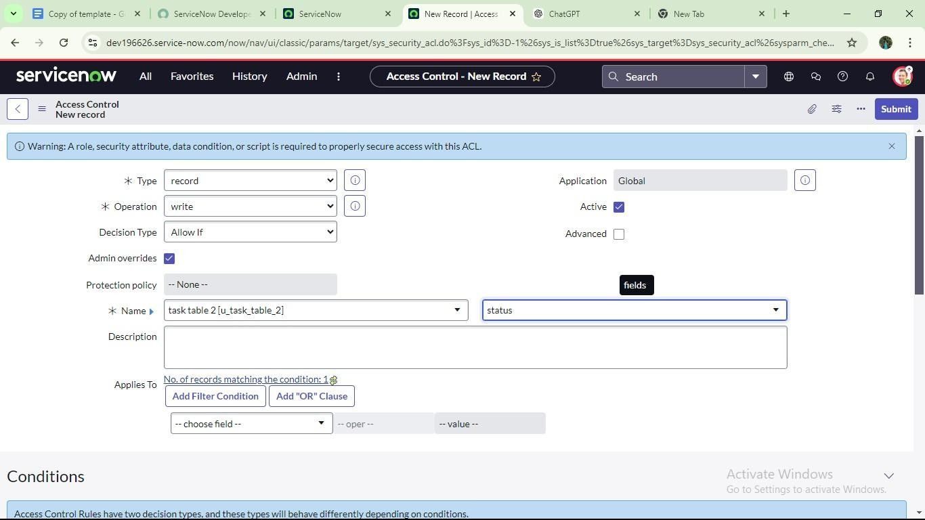Clickonelevaterole 5.Clickon new
5. Fillthefollowingdetailstocreate anewACL
6. Scrolldownunderrequiresrole
7. Doubleclickoninsertanewrow
8. Givetasktableandteammember role
9. Clickon submit
10. Similarlycreate4aclfor thefollowingfields

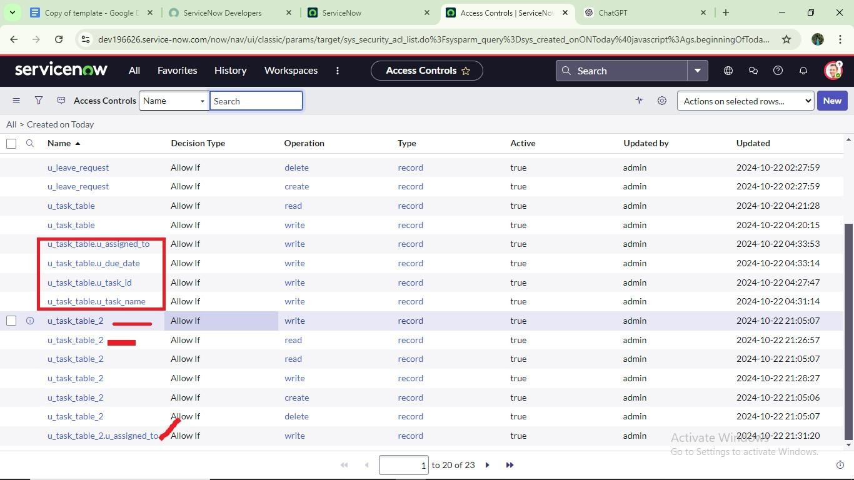

1. Clickonprofileontopright side
2. Clickonimpersonateuser
3. Selectbobuser
4. Gotoallandselecttasktable2intheapplicationmenubar
5. Commentandstatusfieldsarehavetheeditaccess

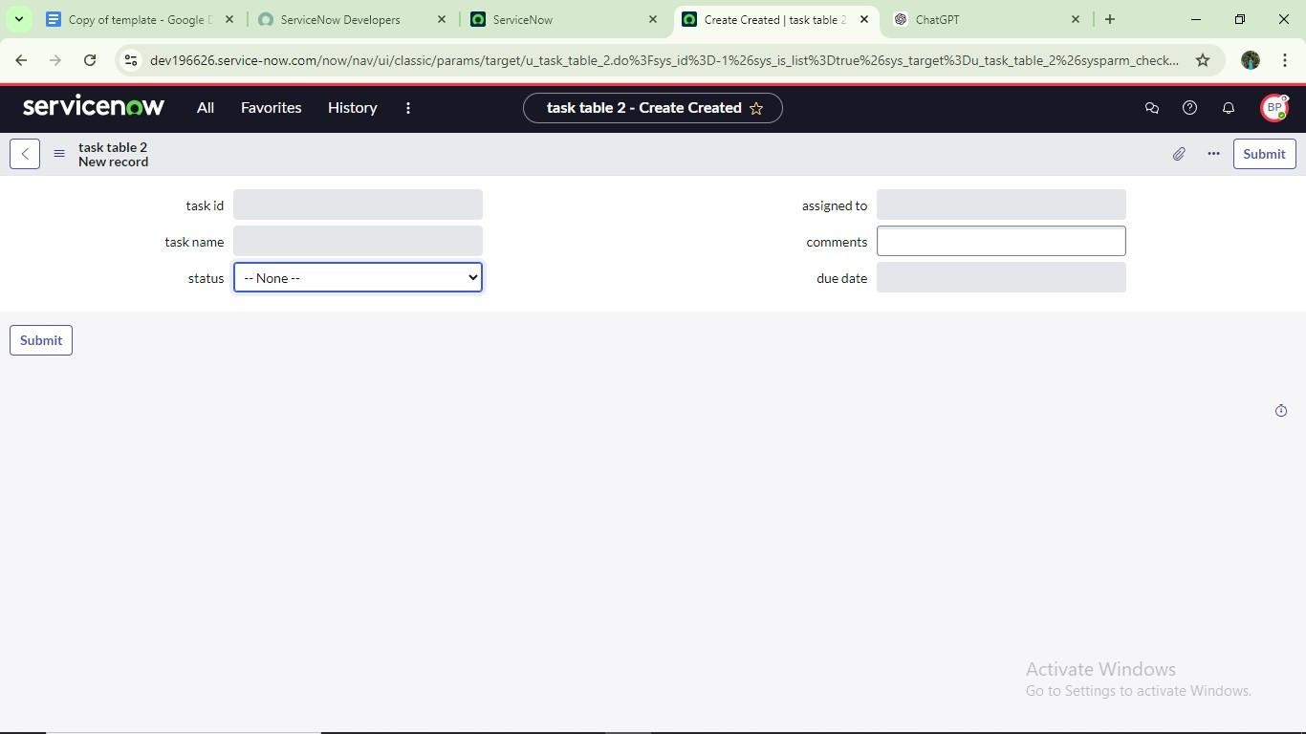

**Milestone9:Flow**

**Activity1:CreateaFlowtoAssignoperationstickettogroup**

1. Openservicenow.
2. ClickonAll>>searchfor FlowDesigner
3. ClickonFlowDesignerunderProcessAutomation.
4. AfteropeningFlowDesignerClickonnewandselect Flow.
5. UnderFlowpropertiesGiveFlowNameas“task table”.
6. ApplicationshouldbeGlobal.
7. Clickbuild flow.

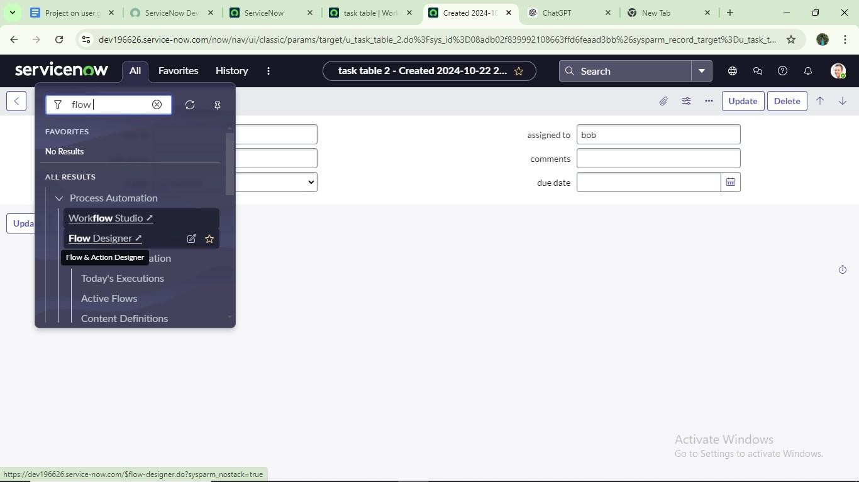

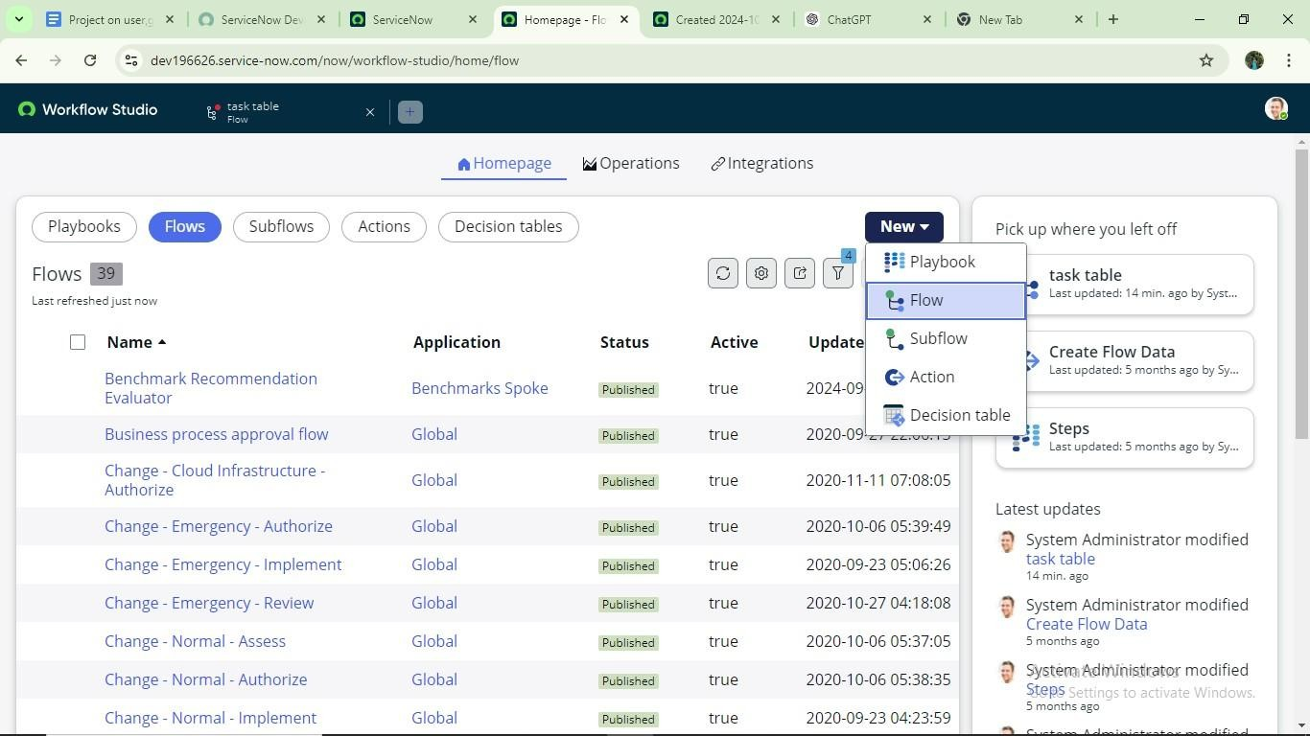

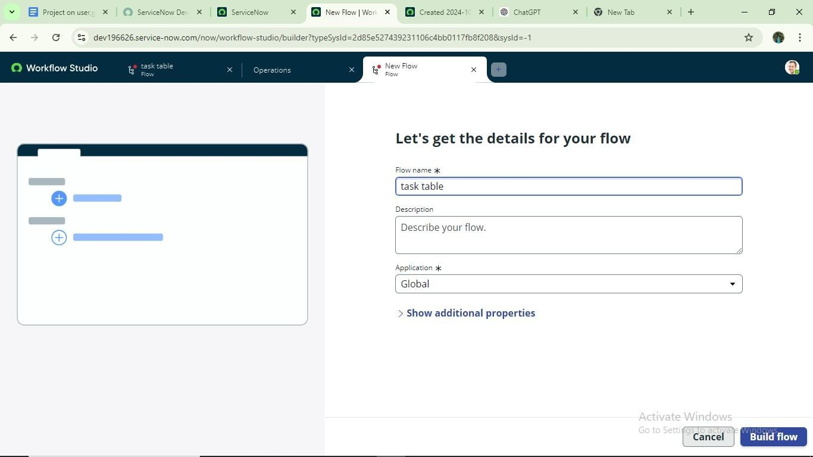

# nextstep:

1. ClickonAdd a trigger
2. Selectthetriggerinthat Searchfor“createrecord”andselectthat.
3. Givethe tablenameas“ task table ”.
4. GivetheConditionasField:statusOperator:isValue:inprogress Field : comments Operator :is Value : feedback

Field:assignedtoOperator:isValue:bob

1. AfterthatclickonDone.

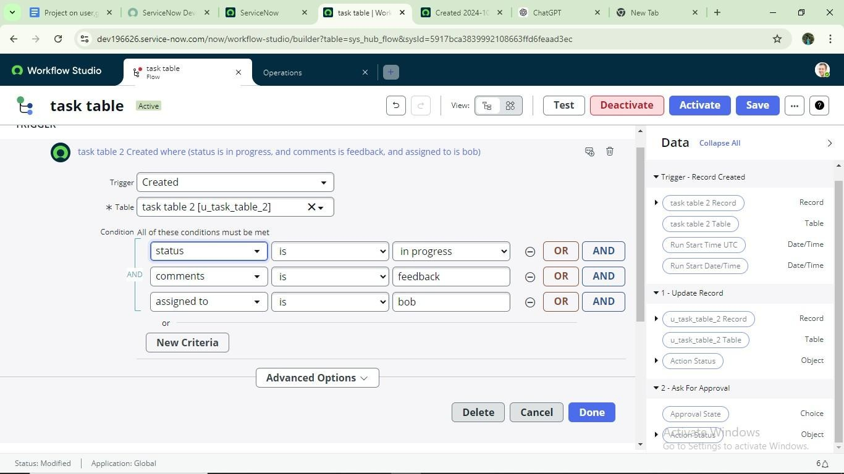

# Next step:

1. ClickonAddan action.
2. Selectactioninthat,searchfor“update records”.
3. InRecordfielddragthe fieldsfromthedatanavigationfromRightSide(Datapill)
4. Tablewillbeautoassignedafterthat
5. Addfieldsas“status” andvalueas “completed”
6. Clickon Done.

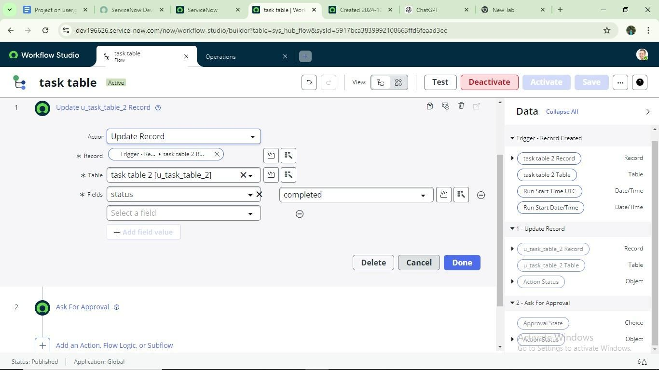

# Next step:

1. NowunderActions.
2. ClickonAddan action.
3. Selectactioninthat,searchfor“askforapproval”.
4. InRecordfielddragthe fieldsfromthedatanavigationfromRightside
5. Tablewillbeautoassignedafterthat
6. Givethe approvefield as“status”7. Give approverasalicep
7. Clickon Done.

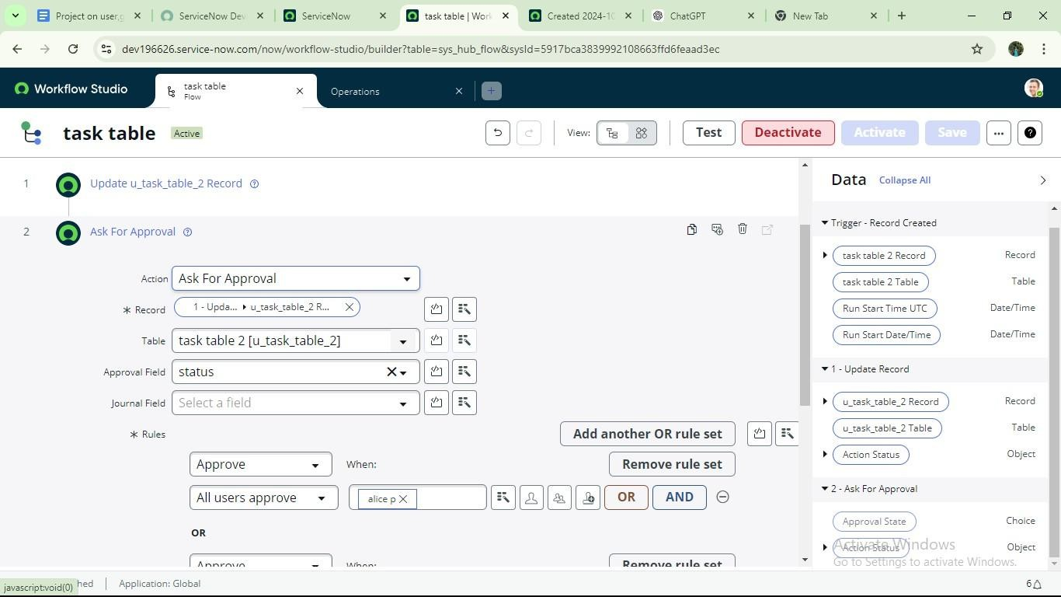

1. Gotoapplicationnavigatorsearchfortasktable.
2. Itstatusfieldisupdatedto completed

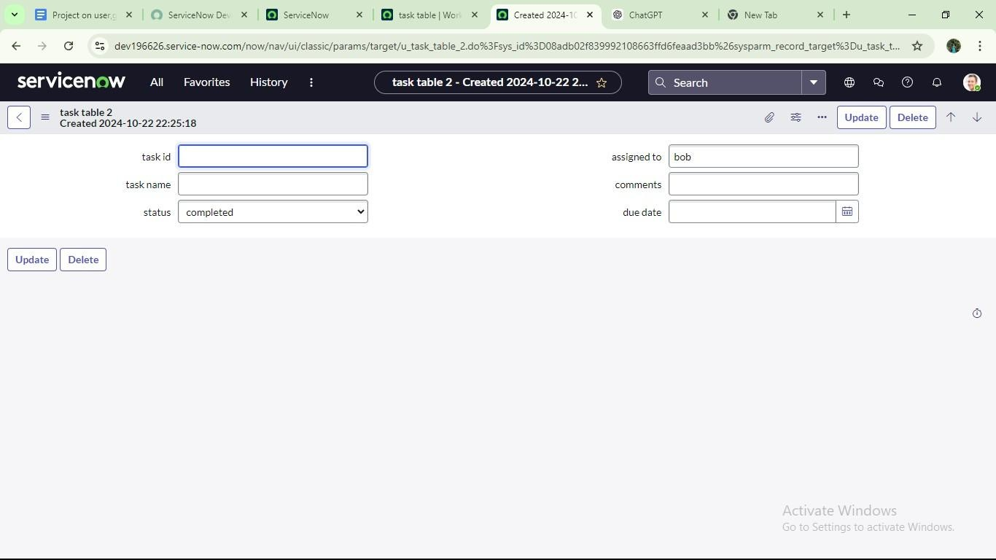

1. Gotoapplicationnavigatorandsearchformy approval
2. Clickonmyapproval undertheservicedesk.
3. Alicepgot approvalrequestthen rightclickonrequestedthenselect approved

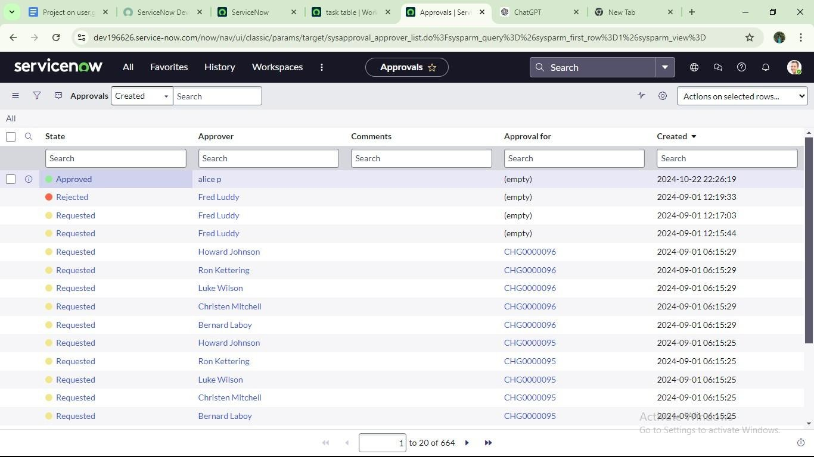

**Conclusion:**

In this project, we have successfully designed and implemented a comprehensive system to optimize user, group, and role management by integrating robust access control mechanisms and streamlined workflow processes. The solution enhances organizational security, operational efficiency, and compliance by ensuring that only authorized users have appropriate access to resources, based on clearly defined roles and responsibilities.

Through the application of principles such as Role-Based Access Control (RBAC), least privilege, and workflow automation, the system minimizes human error, reduces administrative overhead, and provides a scalable framework for managing permissions across diverse environments. The inclusion of automated approval workflows, audit trails, and policy enforcement further strengthens governance and accountability.

Overall, the project demonstrates how thoughtful integration of access control with workflow management not only secures digital assets but also contributes to smoother operations and better user experience. This foundation can be further extended with future enhancements such as integration with identity providers, adaptive access policies, and advanced analytics for continuous improvement.